

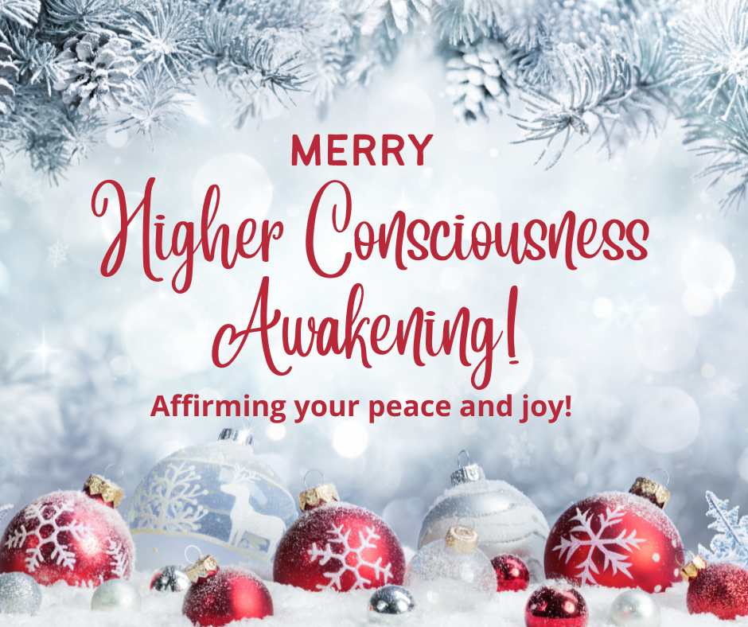



Candlelight Celebration
Spiritual Café
2019
Created by Revs. Drs. Bil and Cher Holton
The Global Center for Spiritual Awakening
1405 Autumn Ridge Drive, Durham, NC 27712

919-530-9417 • GCSAcommunity.org

The Core Ability of Questioning Unquestioned Answers:

I claim my ability to Question Unquestioned Answers now. Today, I remain curious and open to incredible opportunities to enter the realm of enlightened thought. I make it a habit of always questioning what is already known—always seeking the highest Truth. I claim Questioning Unquestioned Answers to express my Extraordinary Nature now!

The Core Ability of Self Reliance:

I claim my Self-Reliance now. Today, I honor my Inner Lotus of Control by trusting in my talents, skills, education, intuition, experience, and instincts. I control my destiny by ensuring my Human Nature is aligned with my Extraordinary Nature. I have control over my response to all the events in my life—and I choose to use all things for good. I claim my Self Reliance to express my Extraordinary Nature now!

The Core Ability of a Giving Consciousness:

I claim my Giving Consciousness now. Today, I honor my Giving Consciousness by rejoicing in every opportunity for giving, with no attachment to an outcome and no expectation of return. I offer all my gifts generously to support people and organizations, to cultivate good will, to help make other people happier, and to bring the joy of generosity to the world. I claim my Giving Consciousness to express my Extraordinary Nature now!



Let the Extraordinary Nature that is the Truth of
who you are shine forth as you walk the
Spiritual path on positive, practical, prosperous feet!
Extraordinary You Candlelight Experience
* * * Affirmations * * *
The Core Ability of Authentegrity:

I claim my Authentegrity now. Today, I refuse to allow doubt or fear to have a space in my consciousness. I stand firmly in my Authentegrity, keeping my priorities in line with my spiritual beliefs and values. I have the confidence to stand in my Truth, and “be the True Me” in everything I do. I claim my Authentegrity to express my Extraordinary Nature now!

The Core Ability of Intuitive Wisdom:

I claim my Intuitive Wisdom now. Today, I make time to go into the Silence and call on my highest levels of perception and understanding. “I know that I know that I know”—and am tuned into the frequency of the Infinite. With this Intuitive Wisdom I can master the art of living in skin school. I claim my Intuitive Wisdom to express my Extraordinary Nature now!

The Core Ability of Inner Strength:

I claim my Inner Strength now. Today, I will consistently honor my Inner Strength and I will not give up or give in! I stand strong in my Inner Strength to accomplish what is mine to do with patience, poise, and practicality. I am resilient. I am strong. I claim my Inner Strength to express my Extraordinary Nature now!

The Core Ability of an Optimistic Spirit:

I claim my Optimistic Spirit now. Today, I honor my incurable optimism and positive outlook on life. I think positive thoughts, make optimistic choices, and take life-affirming actions. I know with confidence that I can Divinely Order every experience and use my innate Core Abilities and Spiritual Principles to work all things together for good! I claim my Optimistic Spirit to express my Extraordinary Nature now!

